**Requirement Analysis**

**Technology Stack (Architecture & Stack)**

|  |  |
| --- | --- |
| Date | 19 June 2025 |
| Team ID | LTVIP2025TMID53033 |
| Project Name | ShopSmart: Your Digital Grocery Store Experience |

**Technical Architecture:**

The technical architecture for ShopSmart is designed using the MERN stack, ensuring a scalable, modular, and responsive full-stack solution for grocery shopping. The architecture consists of user-facing interfaces, application logic handled by server-side code, and persistent data storage through a NoSQL database. This architecture ensures a seamless flow of information and interactions for customers, sellers, and administrators.

**Architecture Diagram:**

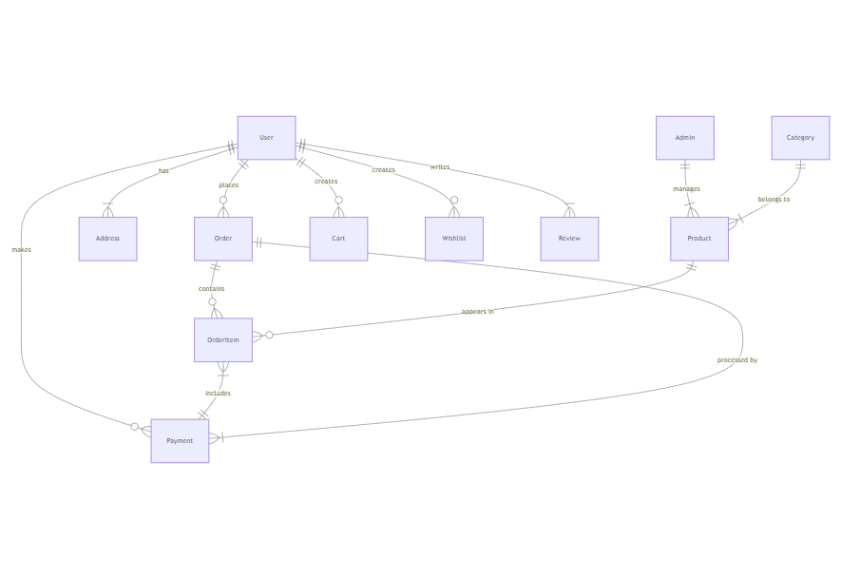**ER-Diagram:**

**Technical Architecture:**

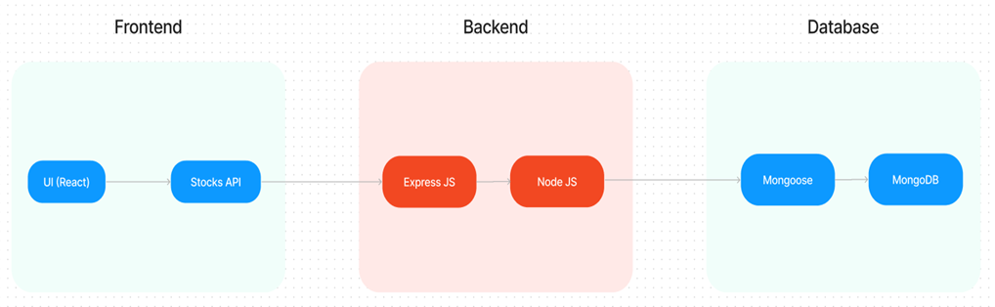

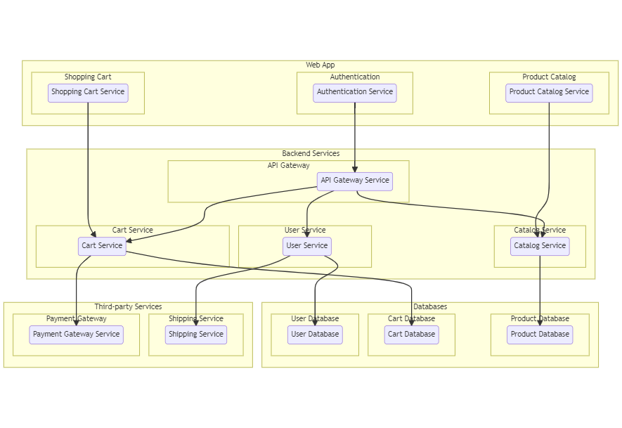

**Table-1: Components & Technologies**

|  |  |  |  |
| --- | --- | --- | --- |
| **S.No** | **Component** | **Description** | **Technology** |
| 1 | User Interface | Web UI for customers, sellers, and admins | HTML, CSS, JavaScript, React.js |
| 2 | Application Logic-1 | User authentication, registration, role-based access | Node.js, Express.js |
| 3 | Application Logic-2 | Order processing, cart handling, inventory management | Node.js, Express.js, Mongoose |
| 4 | Application Logic-3 | Admin control panel with full CRUD operations | Node.js, Express.js |
| 5 | Database | Persistent data storage for users, products, carts, orders | MongoDB |
| 6 | Cloud Database | Optional for deployment (MongoDB Atlas) | MongoDB Atlas |
| 7 | File Storage | Product images and static assets | Local filesystem or Cloudinary |
| 8 | External API-1 | SMS/Email Notification for orders | Twilio API / Nodemailer |
| 9 | External API-2 | (Optional) Payment integration | Razorpay / Stripe |
| 10 | Infrastructure | Application deployment | Localhost, Vercel (frontend), Render (backend) |

**Table-2: Application Characteristics**

|  |  |  |  |
| --- | --- | --- | --- |
| S.No | Characteristics | Description | Technology |
| 1 | Open-Source Frameworks | Used for frontend/backend development | React.js, Node.js, Express.js, MongoDB |
| 2 | Security Implementations | JWT Authentication, Bcrypt password hashing, role-based access | JWT, Bcrypt, CORS, HTTPS |
| 3 | Scalable Architecture | Modular design following a 3-tier architecture | MERN Stack, RESTful APIs |
| 4 | Availability | 24/7 uptime goal, deployment on reliable services | Vercel, Render, MongoDB Atlas |
| 5 | Performance | Fast API responses, optimized rendering, efficient DB queries | Axios, React Hooks, Caching (local) |